SCA TEST DESCRIPTION AND OUTPUT

1. BUILDING IMAGE: the image below shows the building of the scaimage from the Dockerfile which has 2 commands. First to pull base image(nginx) and secondly to add the file in the webpage folder to the target path.

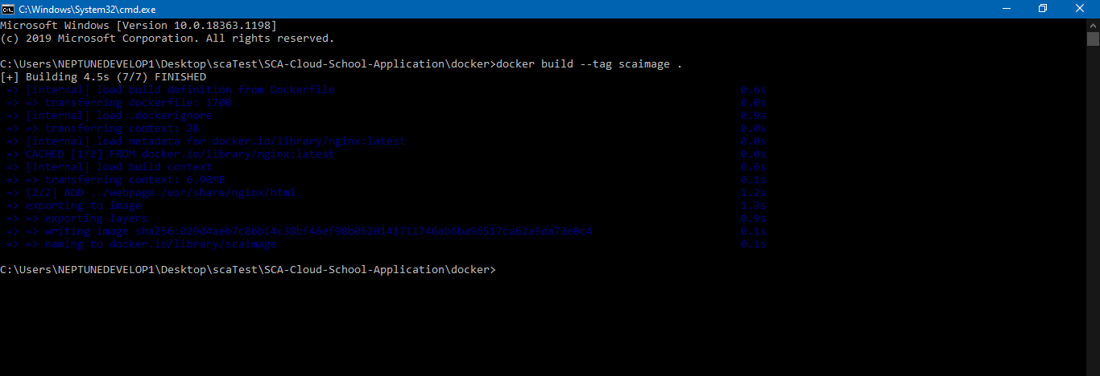

1. RUNNING THE CONTAINER: the image below shows the running of the container (scacontainer) on port 8083 of image (scaimage).

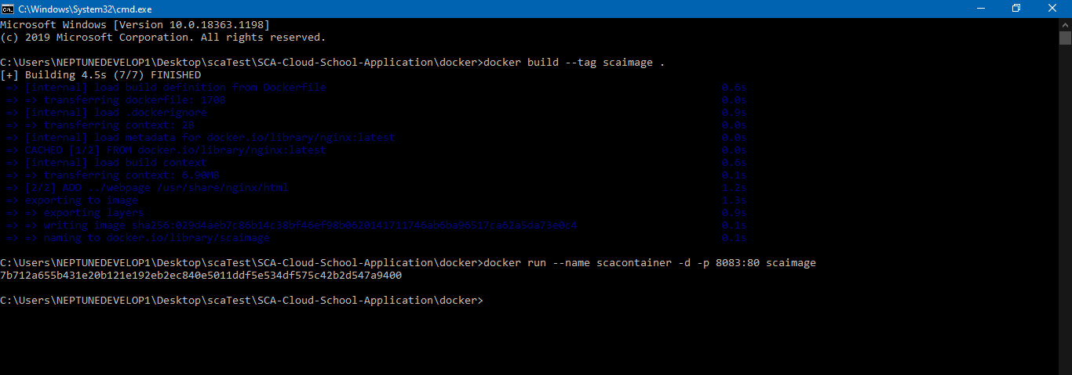

1. VIEWING CONTAINERS AND IMAGES LIST: the images below shows the list of images and containers in the running docker.

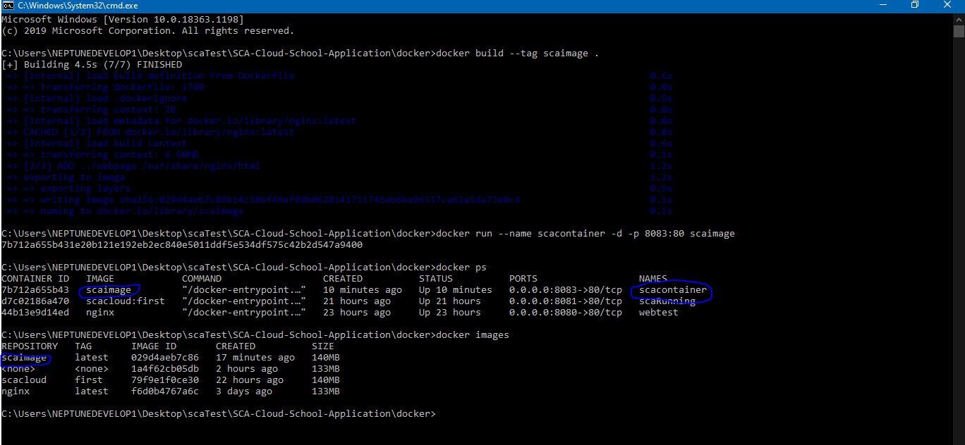

1. TESTING WEBPAGE: the image below shows the content of webpage folder which was added to the base image location.

